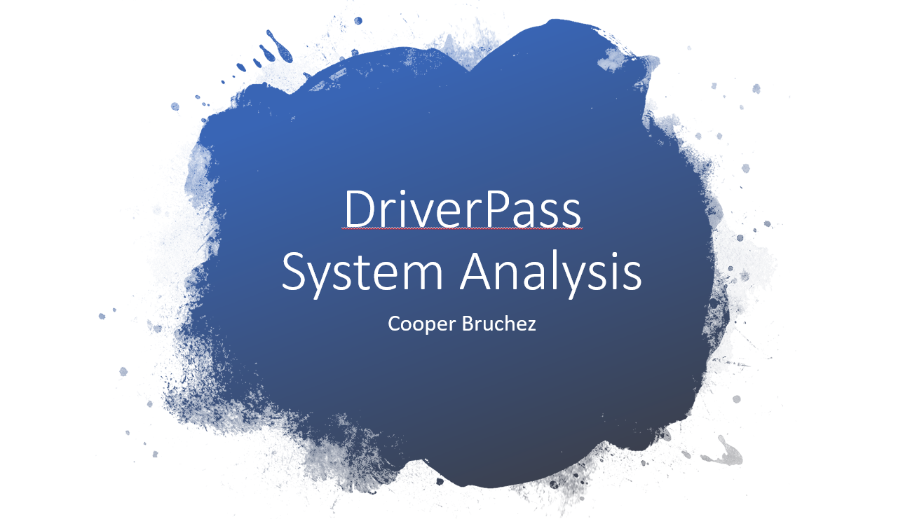
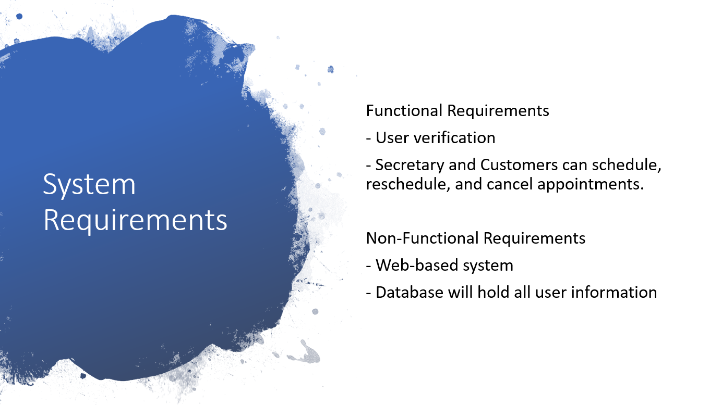
Speaker Notes
- The first and most important functional requirement for the DriverPass system is user verification. It is imperative that users can reliably log in to their accounts as it has quite a bit of their own sensitive information such as payment information, home address, and phone number. It’s important that nobody else accesses their account either maliciously or by accident. By having a user verification system, we can ensure that that doesn’t happen.
- The second important functional requirement is that both the secretary and the customer are able to schedule, reschedule, and cancel appointments. This will allow users to manage their appointments online or over the phone with the secretary.
- The most important non-functional requirements are that the system will be web-based and will utilize a database that holds all user information. The system being web-based both simplified changes made in the future but also ensures a wider range of compatibility with less work needed to make those changes work on all types of devices. The Database is simply required as we will be holding a lot of user information, such as login information, and the system will need to be able to access that whenever user’s login, schedule appointments, or purchase packages.
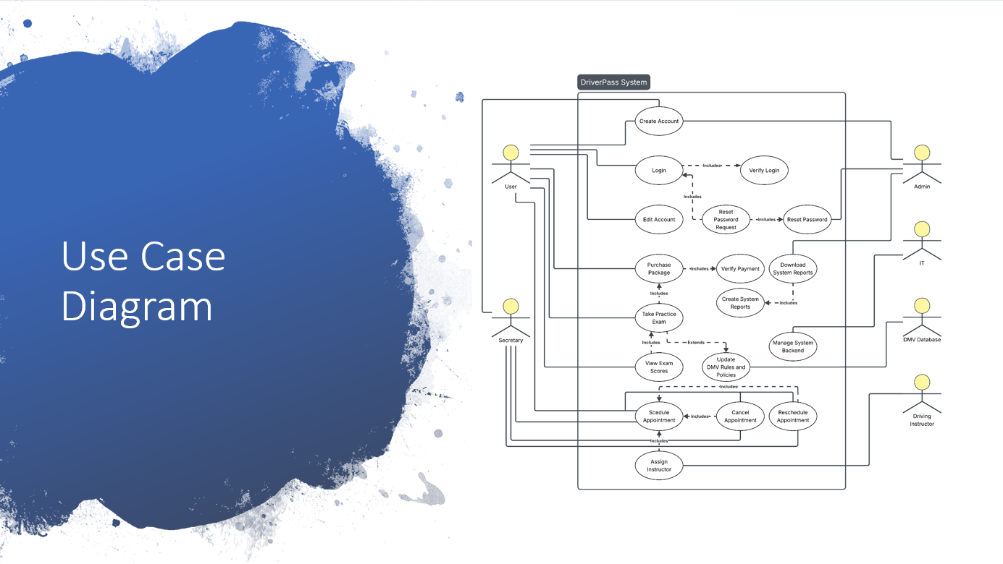
Speaker Notes
- There are many different people and systems that will be interacting with the DriverPass system, and they all need access to different parts of the system. Customers will need to be able to log in to their accounts and request a password reset if needed. They will also need to be able to schedule their appointments but also have the option to reschedule or cancel their appointments if needed. On top of that they will need to be able to purchase the various packages we offer and then once those packages are purchased, they will need to be able to access the content within those packages. All payments within the system will be verified of course and those verifications will be sent back to the customers. It’s also important that the content within packages is up to date. This part of the system relies on the DMV Database which we will use to keep all our practice tests and driving instructions up to date.
- Much like the customers, the secretary will need to be able to schedule appointments for the customers, and just like the customers she will need to be able to cancel or reschedule these appointments.
- The Driving Instructors will need to be able to be notified when they are scheduled for an appointment and will need to be able to access that appointment’s pertinent information. Information such as the pickup location, drop-off location, customer name, and what vehicle
is currently assigned for that appointment.
- IT will need to be able to access the backend of the system so that they can make any small changes needed to the system. They won’t have access to low level functionality, but they will need to be able to adjust things here and there to ensure the system continues to run smoothly for years to come.
- The Admin/Owner will need to be able to download system reports, these reports will have information such as reservation history, payments receipts, and any other activity that has taken place within the system. The Admin/Owner is also in charge of resetting user’s passwords. With that he will also need the ability to create new accounts.
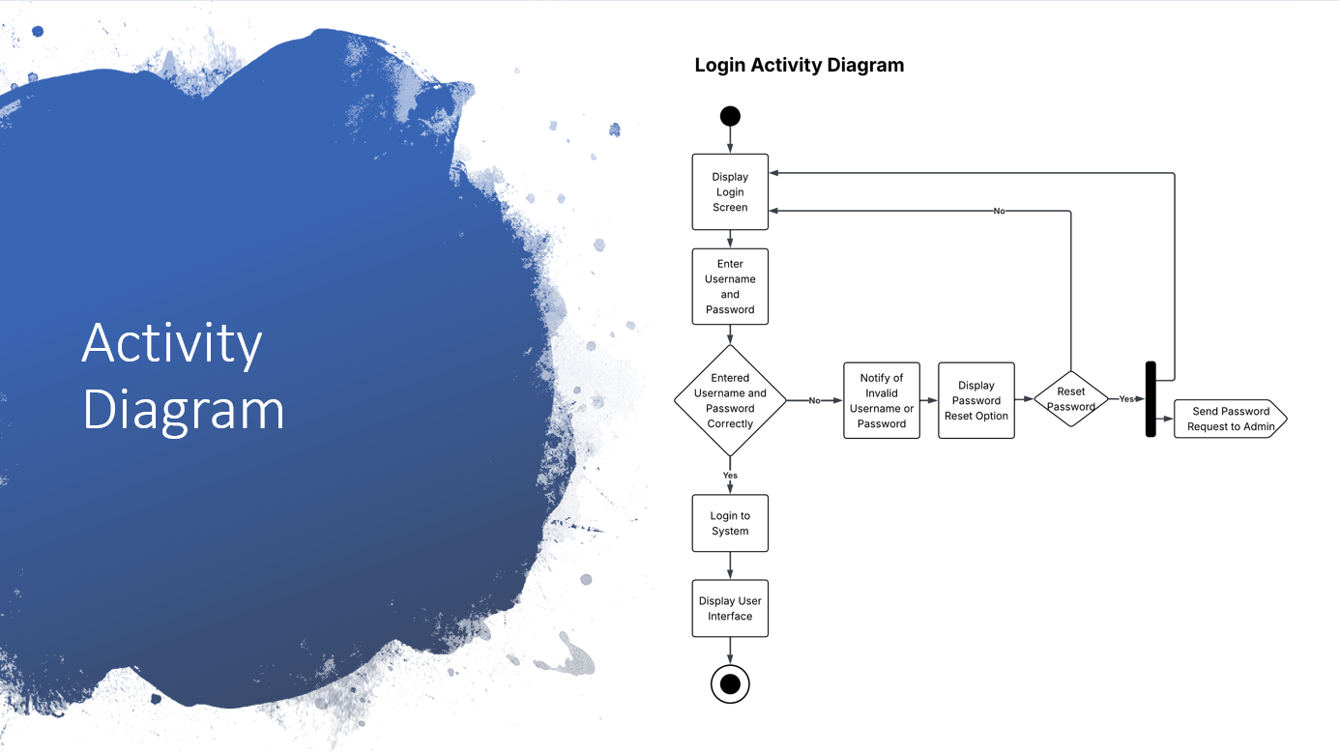
Speaker Notes
- This is a diagram showing how users logging in to the system will work. As you can see it first displays the login screen, the user enters their username and password, and then the system attempts to verify their credentials. In the event that someone's login information is incorrect the system will notify them and ask if they’d like to reset their password. As requested, the system will send all password reset requests to Liam, the owner, so that he can personally reset their passwords. If someone doesn’t want to reset their password, say they just input the login information incorrectly, they can just try to login again. Once a user successfully logs in, they are taken to the DriverPass User Interface and can begin interacting with the system.

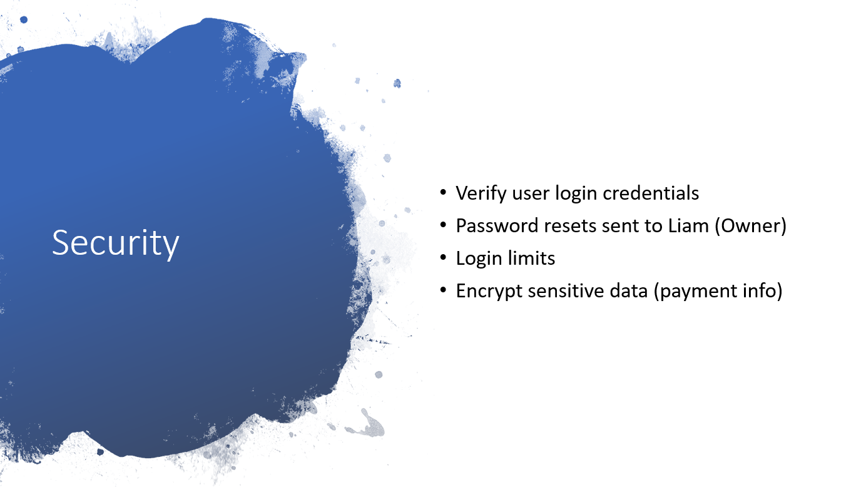
Speaker Notes
- Security was of utmost importance when designing the system. This is why the system will implement a multitude of processes to ensure that user's information, both personal and payment, are as safe as possible. The system will do this by having a strong verification system. With this verification system the only way for a user to reset a password is for them to send a password request directly to Liam. This will help ensure that a bad actor won’t be able to abuse some form of automated system to access a user's information. On top of that we will be implementing a login limit system that will reset after a certain amount of time. This ensures that users who simply mis-input their password have a chance to try again and input it correctly, but someone trying to break into a user’s account by guessing passwords over and over again will be locked out of the system. We will also have an encryption system implemented that will protect users’ sensitive payment information and any other potentially sensitive information. This is of utmost importance as it ensures that even if someone has access to the backend of the system somehow, they won’t be able to access user payment information and will be unable to steal their identity or even just steal credit card information.

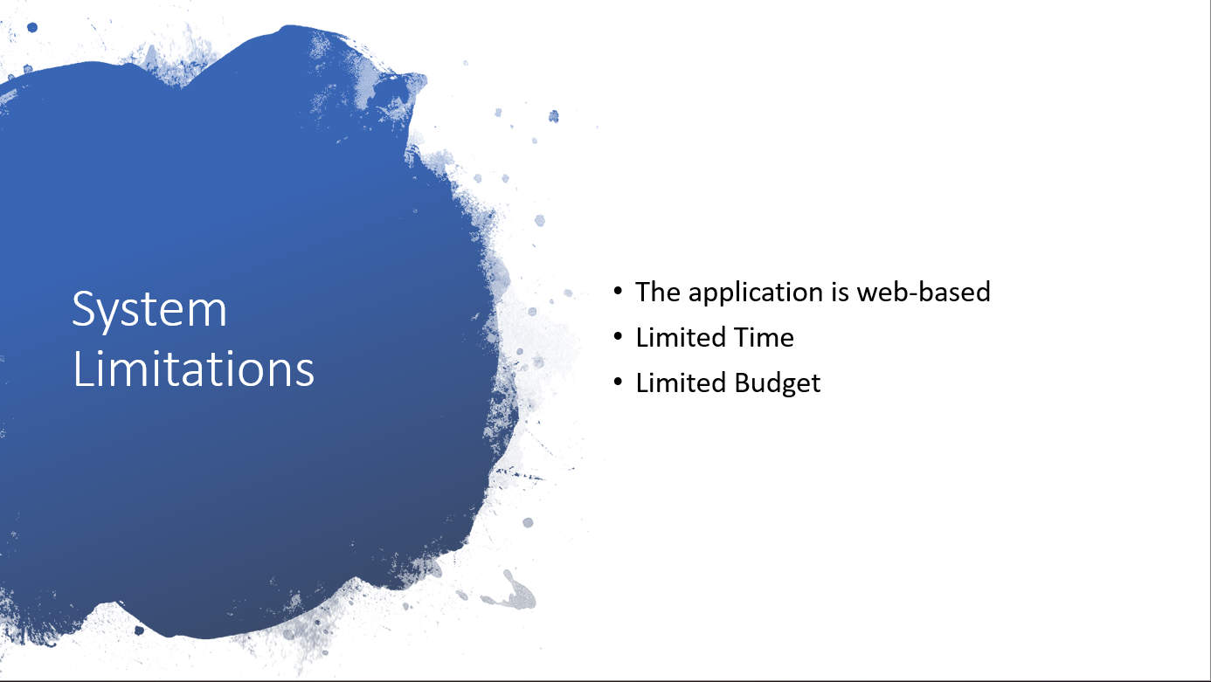
Speaker Notes
- I stated earlier in this presentation that the application being web-based will mean that it will make it much easier for us to make it compatible across multiple devices. This is still true; however, it does mean that we will really need to optimize the system to run on just about any kind of computer. This includes both super computers and 20-year-old desktops. This limits us to using tried and true, albeit simple for the most part, systems in order for it to run properly on all of those machines.
- Time and budget are our other biggest limiting factors. It wasn’t mentioned specifically in the discussion we had with Liam; however, we do have our own milestones set in place for designing the system so keeping on track with those milestones is extremely important. With our current schedule we don’t have a lot of extra time for revisions scheduled so it’s important that we really nail down the specifics of the system before getting too deep into development. With that in mind the budget does get involved with that. The longer we work on it the more expensive it gets so it’s important we hit all of our milestones when we scheduled them.

